**QuizOnn**

A mini-project report submitted for

**Internet Programming (Semester V)**

By

Srushti Pathak (60003160044)

Avdhi Shah (60003160052)

Urvi Shah (60003160057)

As the partial fulfillment of the requirement for the degree of Bachelor in Information Technology

Guided by

Prof. Neepa Shah



Department of Information Technology

D. J. Sanghvi College of Engineering,

Mumbai – 400 056

2018 - 2019



CERTIFICATE

This is to certify that the following students have submitted the mini-project report for the project titled

**QUIZONN**

At D. J. Sanghvi College of Engineering, Mumbai as a partial fulfillment of the requirement for the degree of Information Technology (Semester V) of University of Mumbai in the year 2018 – 2019.

Srushti Pathak 60003160044

Avdhi Shah 60003160052

Urvi Shah 60003160052

Internal Guide Internal Examiner

Prof. Neepa Shah

External Examiner HOD, IT Dept. (Dr. Neepa Shah)



**Declaration**

We declare that this written submission represents our ideas in our own words and where others' ideas or words have been included, we have adequately cited and referenced the original sources. We also declare that we have adhered to all principles of academic honesty and integrity and have not misrepresented or fabricated or falsified any idea/data/fact/source in our submission. We understand that any violation of the above will be cause for disciplinary action by the Institute and can also evoke penal action from the sources which have thus not been properly cited or from whom proper permission has not been taken when needed.

Srushti Pathak - 60003160044

----------------------------------------- -----------------------------------------

Avdhi Shah - 60003160052

----------------------------------------- -----------------------------------------

Urvi Shah - 60003160057

----------------------------------------- -----------------------------------------

----------------------------------------- -----------------------------------------

(Name of student and SAP ID) (Signature)

Date:

# Acknowledgement

The successful completion of this project would not have been possible without the help and guidance of many respected individuals. It gives us great pleasure to express our sincere thanks and gratitude to all of them.

We are extremely grateful to our project in-charge Prof. Neepa Shah for her constant support and encouragement throughout the course of this project.

In addition, we are extremely thankful to our respected Principal, Dr. Hari Vasudevan, and the Head of Department, Prof. Neepa Shah, for giving us the support and guidance to work on this project.

Our thanks and appreciation go to the college and staff for providing us with the necessary resources and valuable suggestions.

Our classmates and team members, have given valuable inputs to this proposal which further gave us an inspiration to improve our project. We thank them all for their help to complete our project.

We express our sincere heartfelt gratitude to each of the individuals who helped us in successfully developing our project within the prescribed time.

**Abstract**

The concept of quizzes is currently very popular among educated circles as well as in entertainment shows. Though the quiz can be conducted manually, it often needs elaborate preparations. Quizzes contribute to the growth of knowledge of an individual and they are a popular source of entertainment. The final output is envisioned to be a user-friendly interactive quiz with which the user can gain significant knowledge and get entertainment with value-addition.

# List of Figures

|  |  |  |
| --- | --- | --- |
| **Figure No** | **Figure Title** | **Page No** |
| 2.1.1 | Site Map | 11 |
| 3.1.1 | Site Structure | 13 |
| 3.1.2 | Navigation | 13 |
| 3.1.3 | Page Layouts | 14 |
| 3.1.4 | Database Tables | 17 |
| 4.1 | Login | 18 |
| 4.2 | Signup | 18 |
| 4.3 | Home | 19 |
| 4.4 | Articles | 19 |
| 4.5 | Sub-categories | 20 |
| 4.6 | Quiz Questions | 20 |
| 4.7 | Profile | 21 |
| 5.1 | Feedback form | 21 |
| 5.2 | Responses | 26 |

# List of Tables

|  |  |  |
| --- | --- | --- |
| **Figure No** | **Figure Title** | **Page No** |
| 1 | TimeLine Chart | 12 |

# Table of Contents

1. **Analysis**
   1. Motivation/Need of the project/Objectives
   2. Problem Definition
   3. Scope
2. **Planning**
   1. Sitemap/ Navigation
   2. Computing environment
   3. Project implementation schedule
3. **Design**
   1. Construction and Design
      1. Designing site structure
      2. Navigation
      3. Page layouts
      4. Database Design
4. **Implementation**
5. **Future Scope**
6. **References**
7. **Assignment No. 01**
8. **Assignment No. 02**

**1. Analysis**

**1.1 Objectives**

The main purpose of this project is to develop an interactive web application to conduct quiz sessions for different topics. The purpose of this recreational game is to provide full-fledged information about a compelling topic. It is an easy way to test knowledge and it is also user friendly website for easy understanding.

This game can be played by people of any age groups but it is specifically meant for people of age between 15 to 35 years. This is because these topics are more relevant to these age groups.

**1.2 Problem Statement**

**Quizzes** can be really addictive, right? When we test our knowledge or our personalities, we can learn more about who we are and what we know. You’re so deeply focused on the subjects that you need to do well in to get into the university you want that one day you take a breather and realise that you don’t know very much else at all. But once your exams are done and the summer holidays roll around, you realise that you haven’t read anything that isn’t a textbook in months and you’re hazy on who the Prime Minister is.

Nor is this a problem restricted to prospective engineers. All subject areas can be similarly prone to this painful intensity of focus. It’s not a bad way to be when you’re deep in exam season. But what happens when you emerge the other side, and decide you want to be a well-rounded human being capable of holding a conversation on topics unrelated to Engineering?

Games these days are totally committed towards entertainment but QuizOnn provides knowledge in fusion with entertainment. In this tedious era QuizOnn provides a dash of entertainment and at the same time also provides complete information about a specific topic the user is interested in. There are games available that provide similar features but fall short in providing attractive user interface and have limited categories. On the other hand, QuizOnn not only provides multiple categories but also one is given an option to select a subtopic included in the corresponding category. Hence the user is rendered with multiple choices. User has only one option of logging in which is using his username and password; but a possible modification can be done where in the user is allowed to login with his facebook, twitter or gmail account. Another possible improvement that can be embedded in the existing system is that a user can compete with other players online.

We provide a game that interests people of all ages. In order to play QuizOnn, the users are required to create an account. Users are awarded for the accuracy and speed of their answer, with a maximum of 20 points awarded per round. Users are also given the freedom to select level according to their potential and see their ranking and scores corresponding to the categories in their profile. Answering slowly or not giving an answer at all results in reduced points or no points respectively. The user will earn one point fewer per second that they wait, with a minimum of 10 points if they answer correctly. Incorrect answers earn zero points but also the user will get the required information related to the topic. We have also included an extra feature of providing detailed information of the selected sub-topic.

Thus QuizOnn provides an overall information of all the general topics and at the same time renders total refreshment.

**1.3 Scope**

**1.3.1 Function and Features**

We provide a game that interests people of all ages. In order to play QuizOnn, the users are required to create an account. Users are awarded for the accuracy and speed of their answer, with a maximum of 20 points awarded per round. Users are also given the freedom to select level according to their potential and see their ranking and scores corresponding to the categories in their profile. Answering slowly or not giving an answer at all results in reduced points or no points respectively. The user will earn one point fewer per second that they wait, with a minimum of 10 points if they answer correctly. Incorrect answers earn zero points but also the user will get the required information related to the topic. We have also included an extra feature of providing detailed information of the selected sub-topic.

Thus QuizOnn provides an overall information of all the general topics and at the same time renders total refreshment.

First of all every user should register in the sign up page using his/her name, email id and by creating username and password. After registering, they need to login every time to access their account. The user is taken to the homepage where he can select a topic from the given categories and can view his profile as well. In a single category, he is further provided with many alternatives; and in a single alternative the user has to answer five questions regarding that topic. The user is given ten seconds to answer each question. He can view his scores in his profile. We have added an additional feature for viewing articles related to the categories to gain extra information.

**2. Planning**

**2.1 Sitemap**

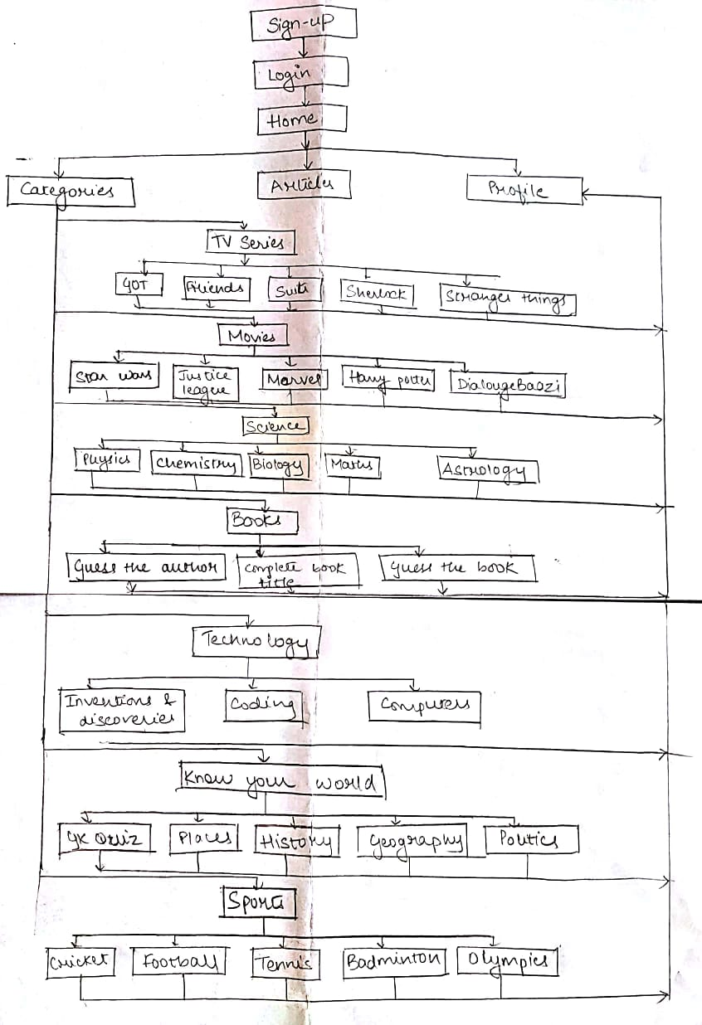

*Fig.2.1.1 Sitemap*

**2.2 Computing Environment**

Software Requirements:

* HTML
* CSS
* JavaScript
* PHP

Tools:

* Windows 10
* Web browser Google Chrome
* XAMPP

Databases:

* MySQL

Hardware Requirements:

* Processor : Intel® Core ™ i5-8250U CPU @ 1.60GHz 1.80 GHz
* Installed memory (RAM) : 8GB
* Storage : 256GB SSD 1000GB (1TB) HDD 1000GB (1TB) HDD + 128GB SSD
* DVD Optical Drive : DVD writer
* Input : Non-backlit keyboard with numeric pad ,Backlit keyboard with numeric pad, Multi-touch trackpad with integrated buttons, Touchscreen
* Speakers and Audio : Stereo speakers
* System Type : 64- bit OS , x64-based processor

**2.3 Project Implementation Schedule**

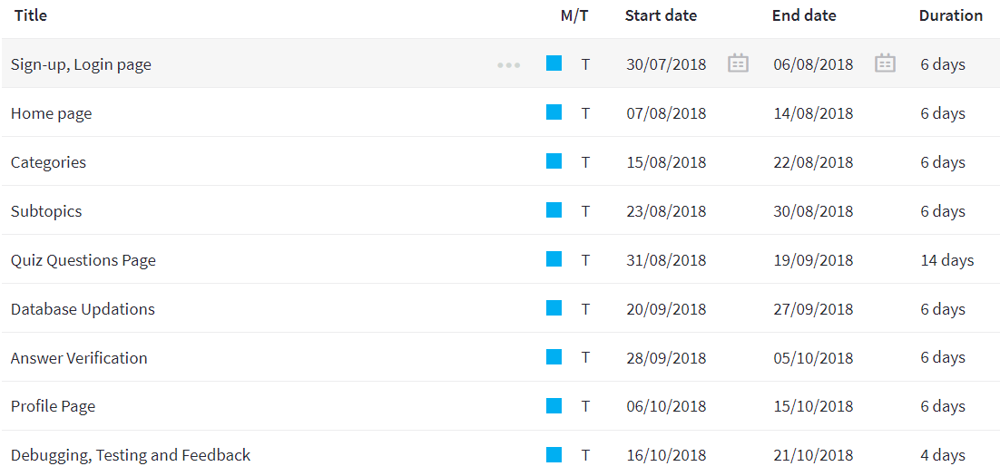

**3. Design**

The architectural design, dependency diagrams, and database schema diagrams are shown in this section.

**3.1 Construction and Design**

***3.1.1 Designing site structure***

The Site Structure is a Graph structure as shown the figure.



*Fig. 3.1.1 Site Structure*

**3.1.2 Navigation**

The main navigation happens through navigation bar.

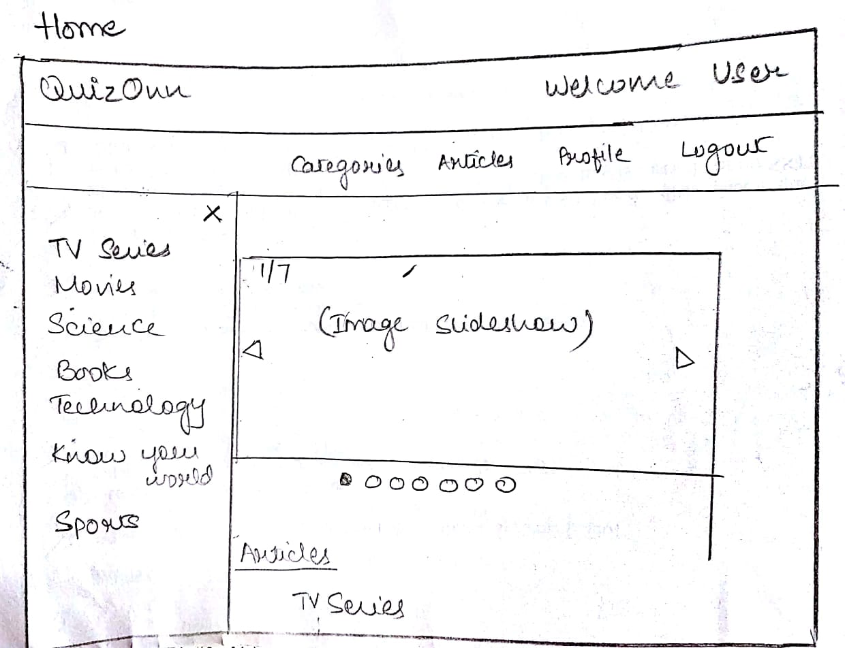

*Fig. 3.1.2 Navigation*

**3.1.3 Page Layouts**

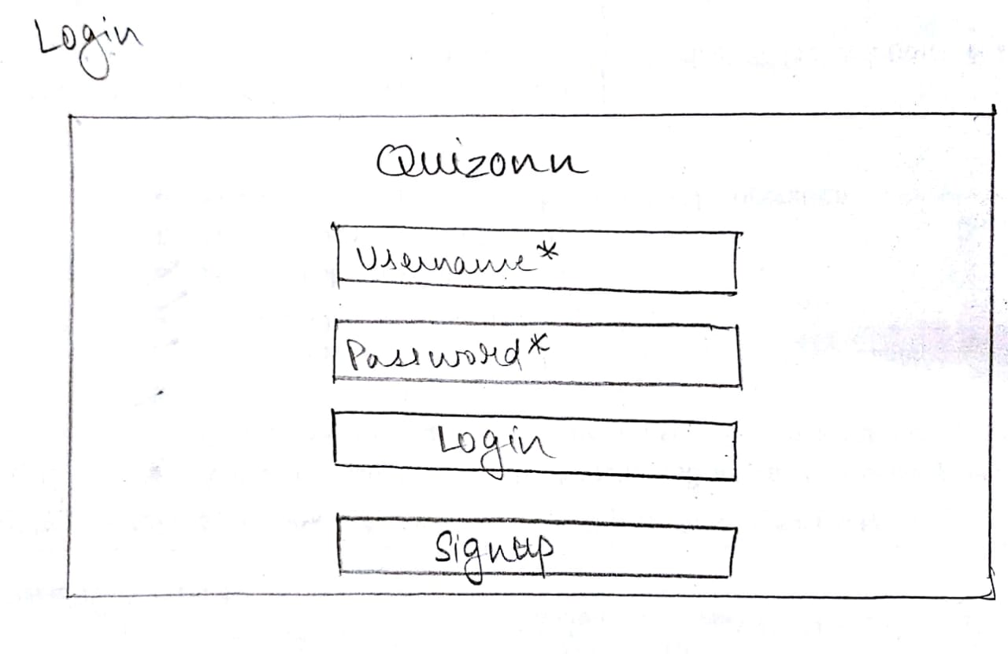

*Fig. 3.1.3.1 Login*

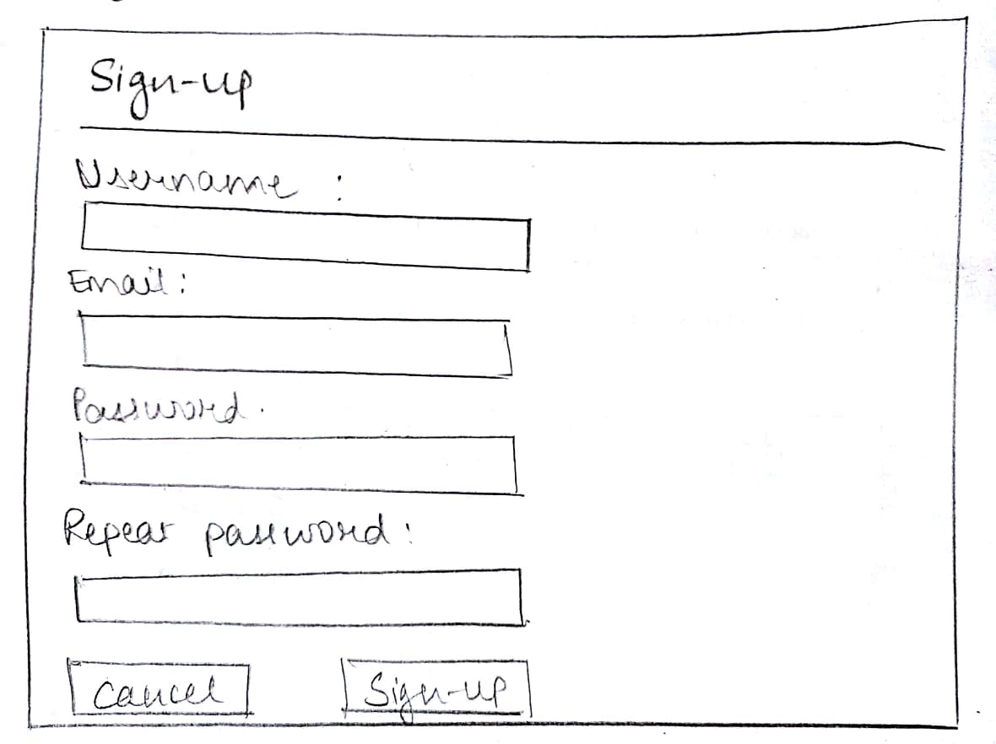

*Fig. 3.1.3.2 Sign up*



*Fig. 3.1.3.3 Home page*

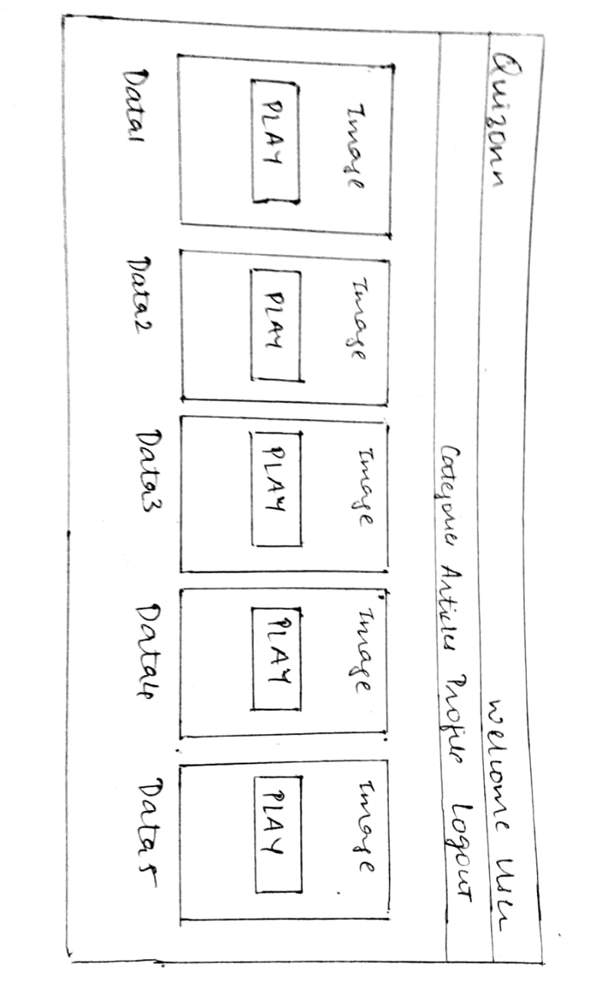

*Fig. 3.1.3.4 Sub-Categories*

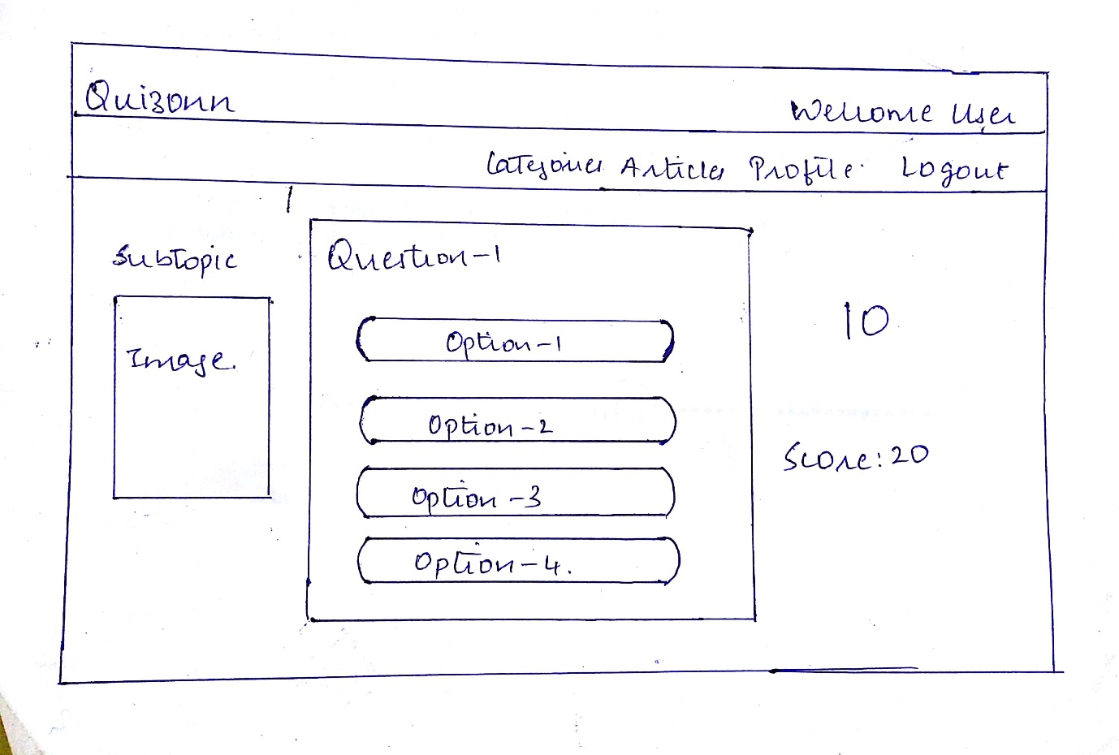

*Fig. 3.1.3.5 Questions*

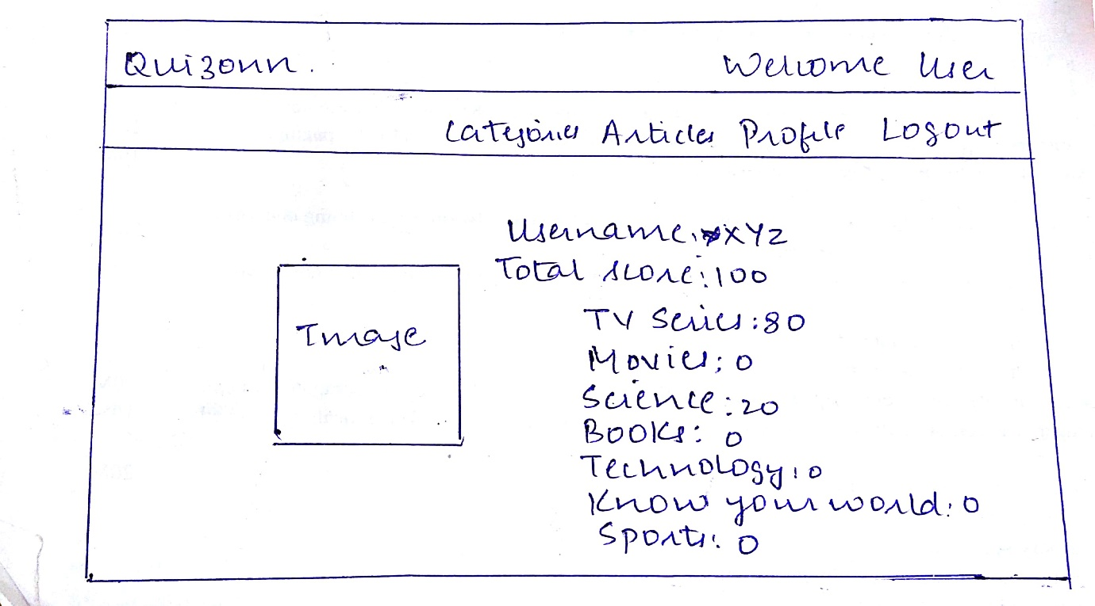

*Fig. 3.1.3.6 Profile*

**3.1.4 Database Design**

The following figures show the database schema. There are three tables in our database.

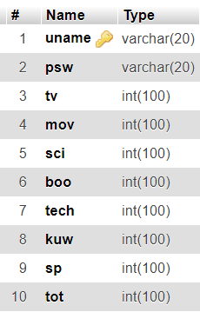 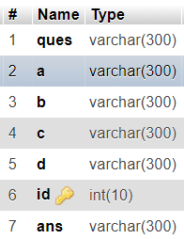 

*Fig. 3.1.4 Database Tables - a) Account table(acc), b) Questions table(qa), c)Table ‘session’*

1. **Implementation**

This section gives detailed information about the site with screenshots and their description.

This is the first page of the website. The user can access the account by logging in to the website.

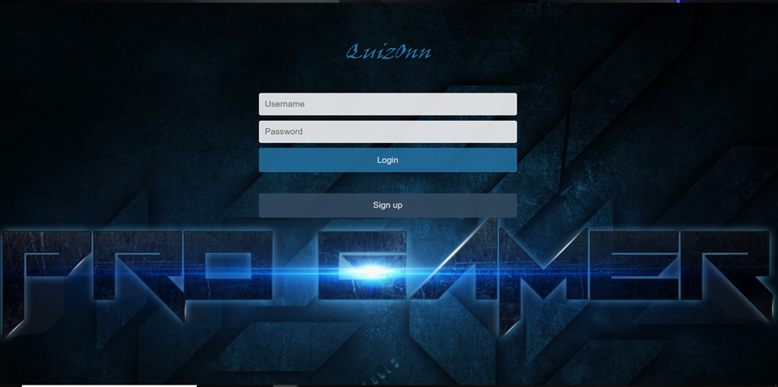

*Fig. 4.1 Login*

This page is for user sign up and create an account on QuizOnn.

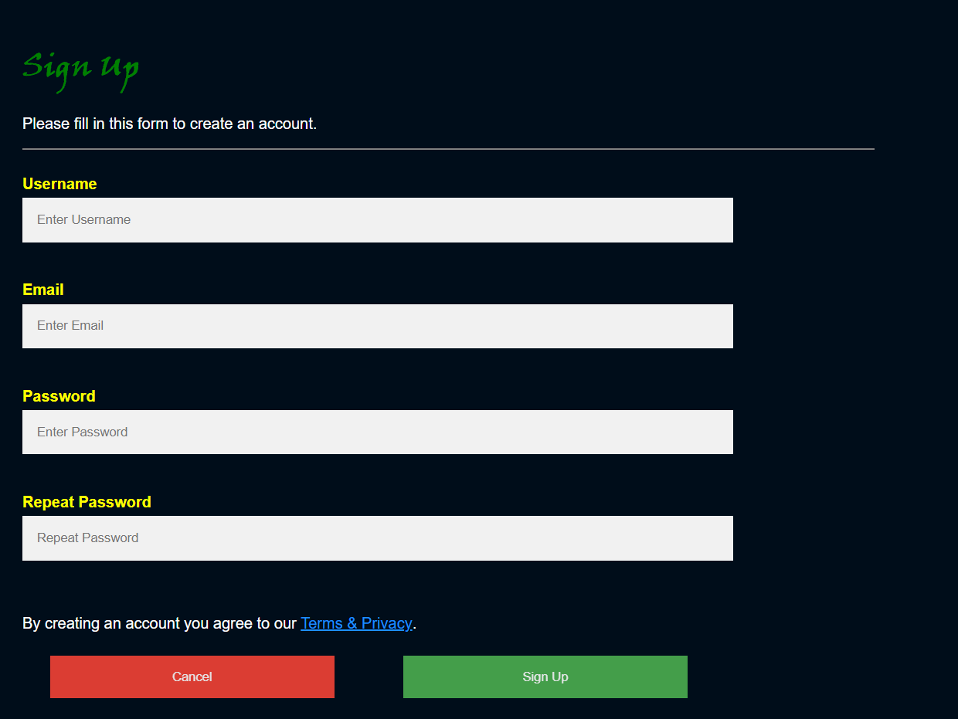

*Fig. 4.2 Signup*

This is an example of Side navigation bar for ‘Categories’.



*Fig. 4.3 Home page (with sidebar)*

When the user clicks ‘Articles’ in navigation bar, this page is displayed below the home page.



*Fig. 4.4 Articles*

This page shows subcategories for a particular category of game. In this case, category is TV series.

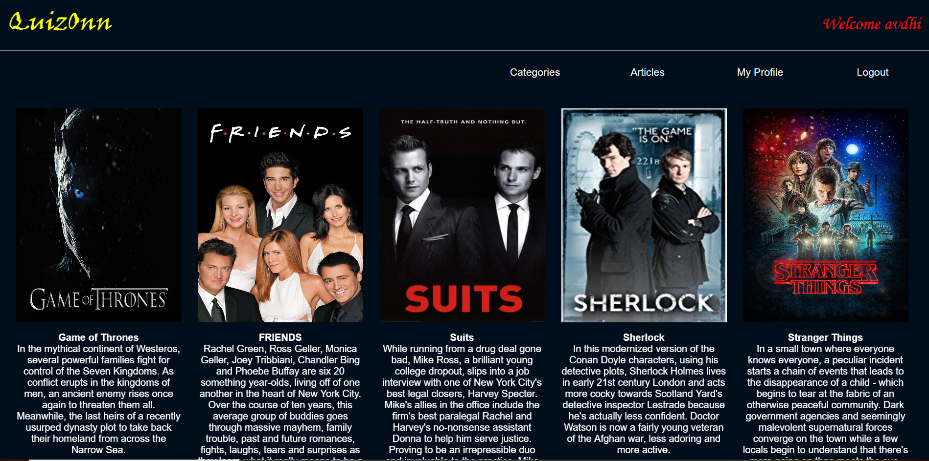

*Fig. 4.5 Subcategories*

On clicking any of the sub-category, the quiz game starts with timer of 10 seconds and 5 questions. The score is updated accordingly.

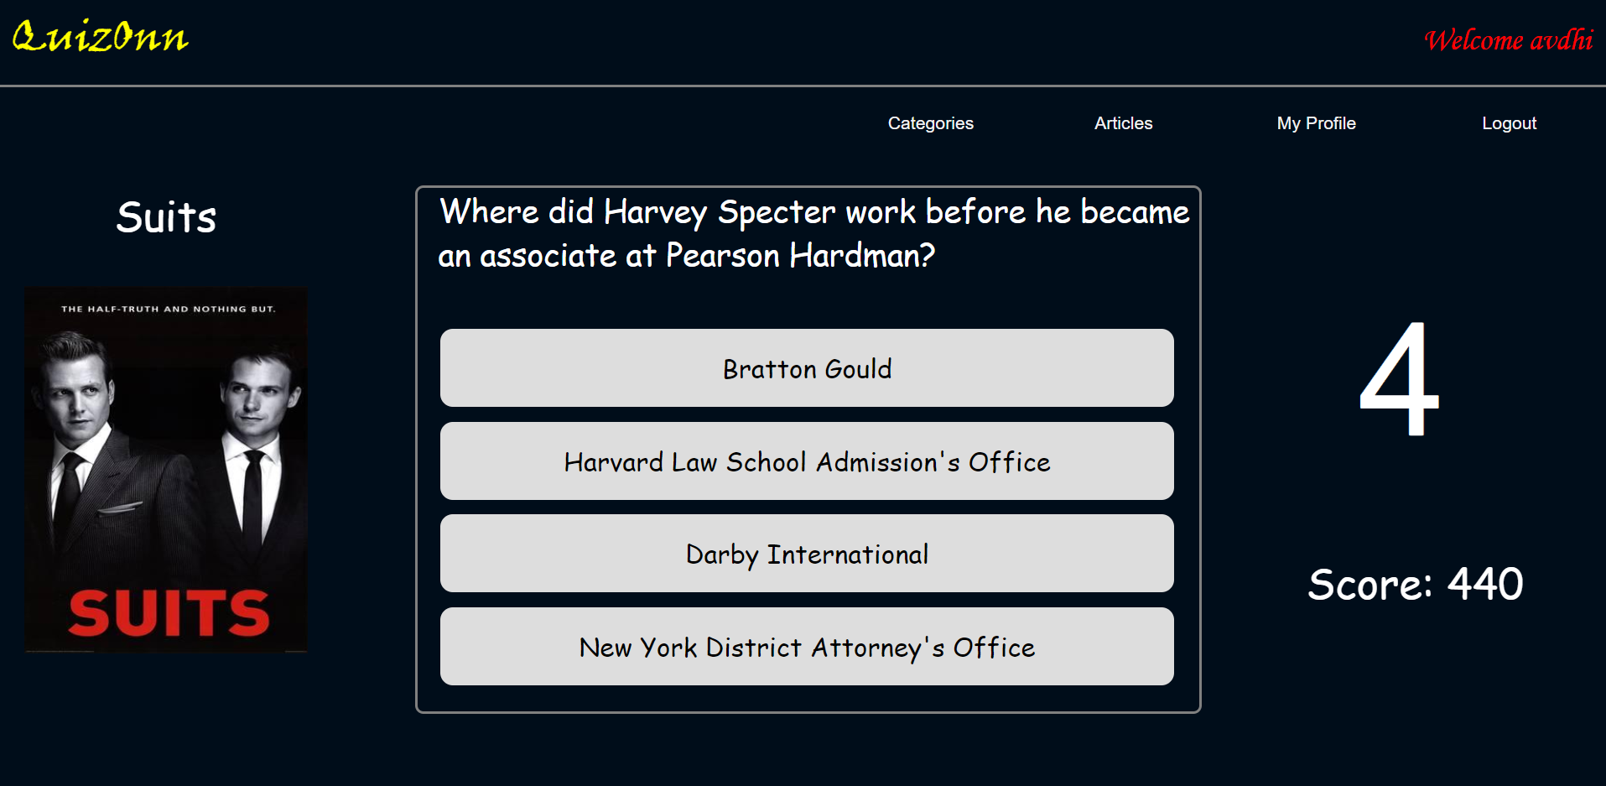

*Fig. 4.6 Quiz Questions*

After the game ends, the final score is updated on the profile page.

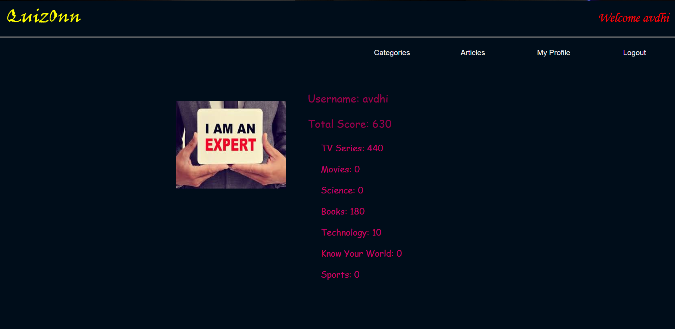

*Fig. 4.7 Profile*

**5. Maintenance**

* **User Manual**
* **Login**

User can login using his username and password.If he does not have an account then he can sign up.

* **1st page**

The 1st page gives the overview of the topics.

There are 7 categories: tv series, movies, science, books, technology, know your world and sports.

The user can select any one category.

* **Category**

The user selects any one subcategory for the selected category.

Five questions randomly selected from the database will be displayed and the user has to answer each question in 10 seconds.

* **Profile**

This page displays the score of the user in each category.

His profile picture changes based on the total score.

* **Articles**

Articles related to the categories are displayed here.

* **User feedback**
  + User feedback link for the website

<https://goo.gl/forms/KbvuZYXVG8ytwarE3>

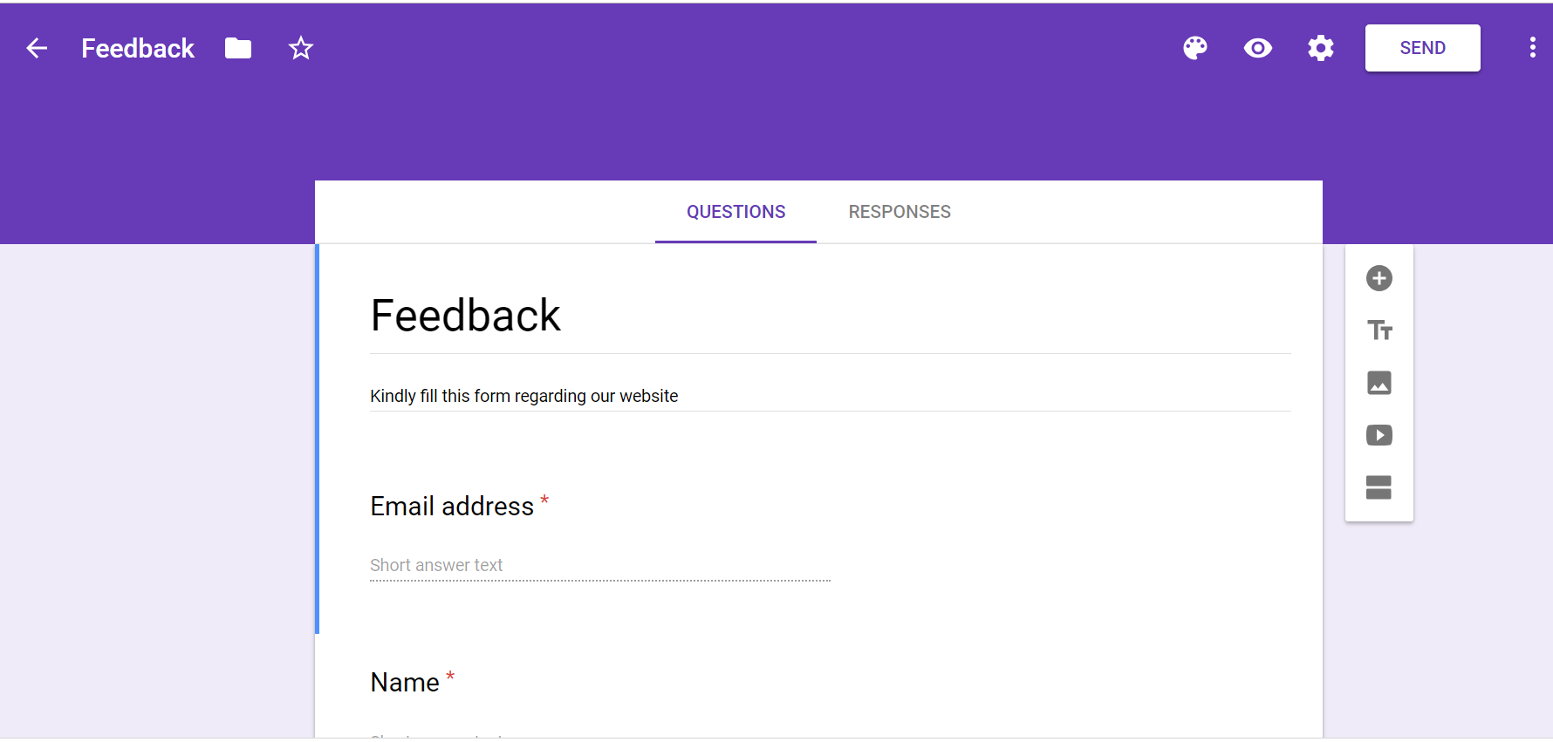

*Fig. 5 Feedback form*

**6. References**

* <http://php.net/manual/en/index.php>
* <https://devdocs.io/html/>
* <https://devdocs.io/javascript/>
* <https://devdocs.io/css/>